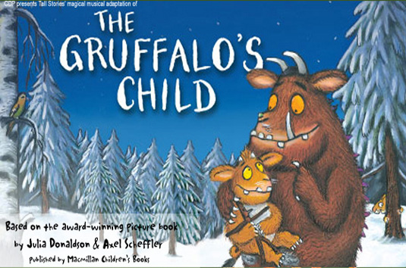
The Gruffalo’s Child
10 & 11 July 10.30am & 1pm
Joan Sutherland Performing Arts Centre, 597 High Street, Penrith
A Magical Musical Adaptation based on the award-winning picture book by Julia Donaldson and Axel Scheffler, published by Macmillan Children’s Books

In the July school holidays The Joan will open its doors for young audiences to experience the magic of The Gruffalo’s Child. Based on the award-winning picture book by Julia Donaldson and Axel Scheffler and the sequel to The Gruffalo, it is a magical, musical adaptation children are sure to love. Aimed at ages 4 and up, the 55 minute production begins on a wild and windy night when the Gruffalo’s child ignores her father’s warning and tiptoes out into the snow.
After all the Big Bad Mouse doesn’t really exist. Does he?...

“...this brave little offspring of the Gruffalo captures the young audience and keeps it entranced.....plenty of audience involvement to keep the kids active and engaged....the production does true justice to the much loved characters...” (Stage Whispers, Sydney)

Brought to you by CDP and Tall Stories - the team behind The Gruffalo and Room On The Broom - the production brings together physical theatre, music and puppetry, with lively songs, laughs and gentle scary fun.

The Gruffalo’s Child at The Joan will be showing at 10:30am and 1:00pm on 10 and 11 July. Tickets are Adult $22 Child $18 Family $72 (four people, at least one adult). Groups are more than welcome – please contact Box Office to arrange bookings, and to find out about complimentary carer tickets for OOSH and child care groups.

To book call our Box Office on 4723-7600 or online at www.thejoan.com.au
Running Time: 55 minutes, no interval

